[1]

The Application of MLP in Nonlinear Function

Shengqi Pan, Student Member

College of Electrical Engineering, Zhejiang University

*Abstract*—In order to solve the low precision prediction problem in conventional method of nonlinear function fitting, BP neural network is applied. After analyzing the BP neural network structure and training process, BP neural network is established by the given nonlinear data, and the software is based on python. The result is manually The simulation reveals that the application of BP neural network in non linear function has a good performance.

*Index Terms*—function fitting, neural networks, proximity, BP algorithm, multilayer perceptron, gradient descent

# INTRODUCTION

N

OWADAYS, the world is filled with plenty of data, so a large amount of data is required to be stored and processed. Specifically, in science research, a lot of data is there to be processed, which urges us to find a way to make full use of the data. More casually, we have to fit a nonlinear function based on the experiment data.

Though the conventional data processing methods perform well in linear function and polynomial function, they may not work well when applied to nonlinear function. So I tried to fit a curve with the help of neural network.

Multi-layer perceptron is a kind of basic neural network, involving an input layer, several hidden layers and an output layer. In MLP, the neurons use non-linear activation functions that is designed to model the behavior of the neurons in the human brain. An multi-layer perception has a linear activation function in all its neurons and uses back propagation for its training. Typically, sigmoid is picked as the activation function of the MLP in this paper.

Numpy is a popular efficient calculation package for python. With numpy applied, the matrixes and vectors can be easily erected and calculated. Since the erecting and training of MLP is based on matrix and vectors, numpy is a good choice for this project.

# Multi-layer perception Networks

1. *Neuron model*

The basic unit of a neural network is a network that has just a single node, and this is referred to as the perceptron. The perceptron is made up of inputs x1, x2, …, xn their corresponding weights w1, w2, …, wn. A function known as activation function takes these inputs, multiplies them with their corresponding weights and produces an output y.

1. *Neural Networks*

Now that the conception of a perception is clear, let’s see how a multilayer perception works. A multilayer perceptron is a class of neural network that is made up of at least 3 nodes. So now you can see the difference. Also, each of the node of the multilayer perceptron, except the input node is a neuron that uses a non-linear activation function. The nodes of the multilayer perceptron are arranged in layers.

1. The input layer
2. The output layer
3. Hidden layers: layers between the input and the output.
4. *The activation function*

The activation function combines the input to the neuron with the weights and then adds a bias to produce the output. In other words, the activation function maps the weighted inputs to the output of the neuron.

One of such activation functions is the sigmoid function which is used to determine the output of the neuron. An example of a sigmoid function is the logistic function which is shown below.

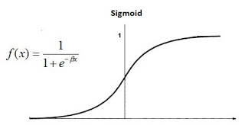

Figure sigmoid function

So with activation function, we can calculate the output of any neuron in the MLP. Assuming w denotes the vector of weights, x is the vector of inputs, b is the bias and φ is the activation function, then for the ith neuron, the output y would be given by:

$$y=\left(\sum_{i=1}^{n}{w_{i}x_{i}}+b\right)=φ\left(w^{T}x+b\right)$$

1. *MLP model*

A typical MLP structure with two hidden layers is shown below:

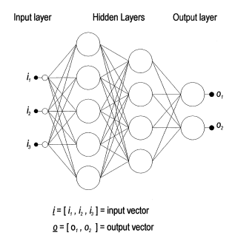

Figure A typical MLP structure

Multilayer perceptron is described as being fully connected, with each node connected to every node in the next and previous layer.

1. *Training process*

By selecting a suitable of connecting weights and transfer functions, it has been shown that a multilayer perception can approximate any smooth, measurable function between the input and output vectors. Multilayer perception possesses the ability to learn through training.

The learning algorithm for the multilayer perception is known as back propagation. The backpropagation training algorithm uses gradient descent to attempt to locate the absolute minimum of the error surface. Backpropagation has been shown to perform adequately in many applications.

The weights in the network are initially set to small random values. This is synonymous with selecting a random point on the error surface. The backpropagation algorithm then calculates the local gradient of the error surface and changes the weights in the direction of steepest local gradient. Given a reasonably smooth error surface, it is hoped that the weights will converge to the global minimum of the error surface.

The backpropagation algorithm is summarized below.

1. Initialize network weights
2. Present first input vector, from training data to the network.
3. Propagate the input vector through the network to obtain an output.
4. Calculate an error signal by comparing actual output to the target output.
5. Propagate error signal back through the network.
6. Adjust weights to minimize overall error
7. Repeat step 2-7 with next input vector, until overall error is satisfactorily small.

# training and optimizing

$y=\sin\left(x\right),x∈[0, 2π]$

To approximate a one-dimensional function, the following MLP neural network is given.

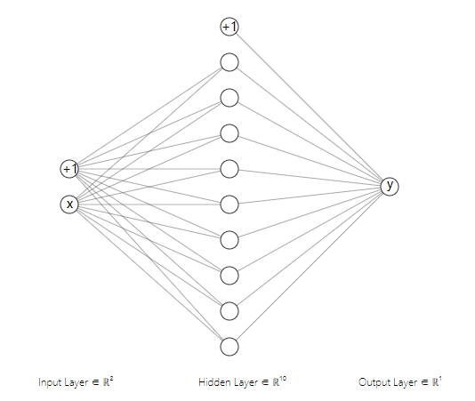

Figure MLP for one-dimensional task

As is shown in the above figure, the MLP consists of one hidden layer with ten neurons, one input layer and one output layer. What needs to be emphasized is that the output layer can be thought as a general neuron but without the activation function. This is because the sigmoid function is a single direction function, which means it can not output negative value. With the sigmoid function removed, the sine function can be fitted.

Apply this network in python and set learning rate as 0.3, epochs as 10000. Then train it with 9 sample input ranging from $0-2π$, whose image is shown below:

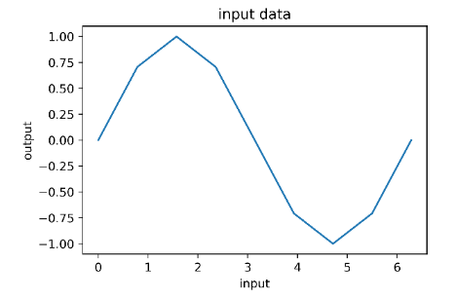

Figure input data

After training 10000 epochs, the neural network can excellently approximate the input sine curve. Plot the target curve and the fit curve in one figure with matplotlib, the result is shown below:

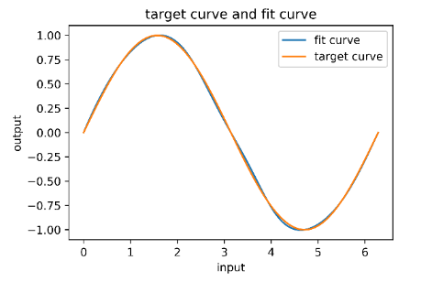

Figure target curve and fit curve

Record the training error in each epoch and plot the training error curve. The x-coordinate is the number of iterations and the y-coordinate is the training error. The figure is shown below:

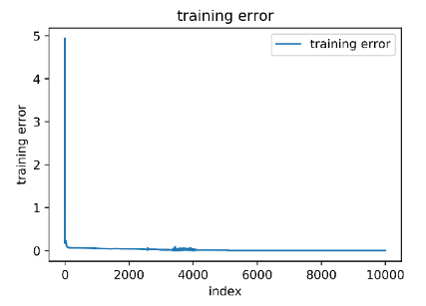

Figure training error

Consider the error of the last iteration, the training error equals $3.465736×{10}^{-15}$

Then test the fit curve with 361 test data uniformly ranging from $0-2π$. Plot the error of each test data, the figure is shown below:

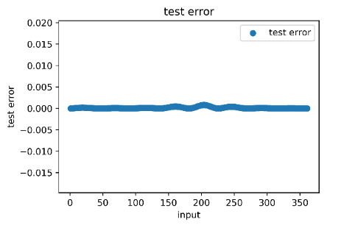

Figure test error

The figure shows that the test error is generally small, which means the fit curve approximates the target curve well. Here consider the average error of the 361 test data, we can come up with the test error. The test error equals $1.323524×{10}^{-4}$

Comparing the test error and the training error, it’s not difficult to find that the test error far outweighs the training error. This is simply because the input data is so scare. One way to solve the problem is to add the number of the input data.

1. How the num of neurons influences the training process

To find out how the numbers of neurons can affect the result of learning, I changed the number of neurons and see how it works.

Firstly, I reduced the num of neurons to 3, the result is shown below:

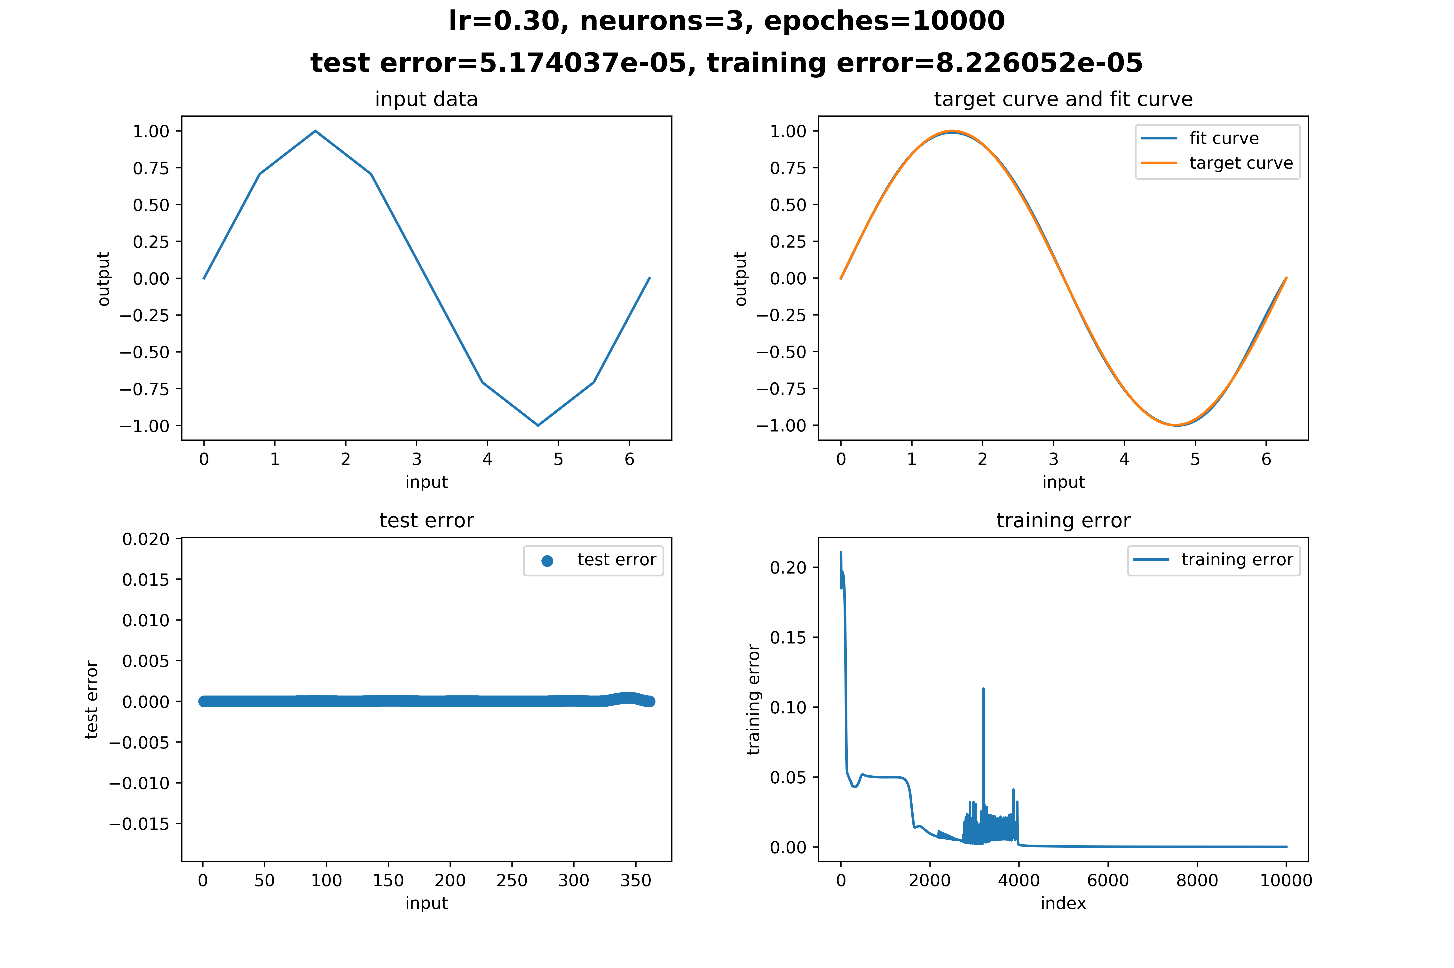

Figure num of neurons = 3

As is shown in the figure, the training error is far more larger than the training in the previous test(when the number of neurons =10), while the testing error is close to the training error in the previous test. From the last figure in the subplot we can find that the training error decreases more slowly than the previous time and also not as smooth as the previous time, which means it bounces a lot of times during the process of training.

Then I reduced the num of neurons further. This time, the num of neurons equals 2.

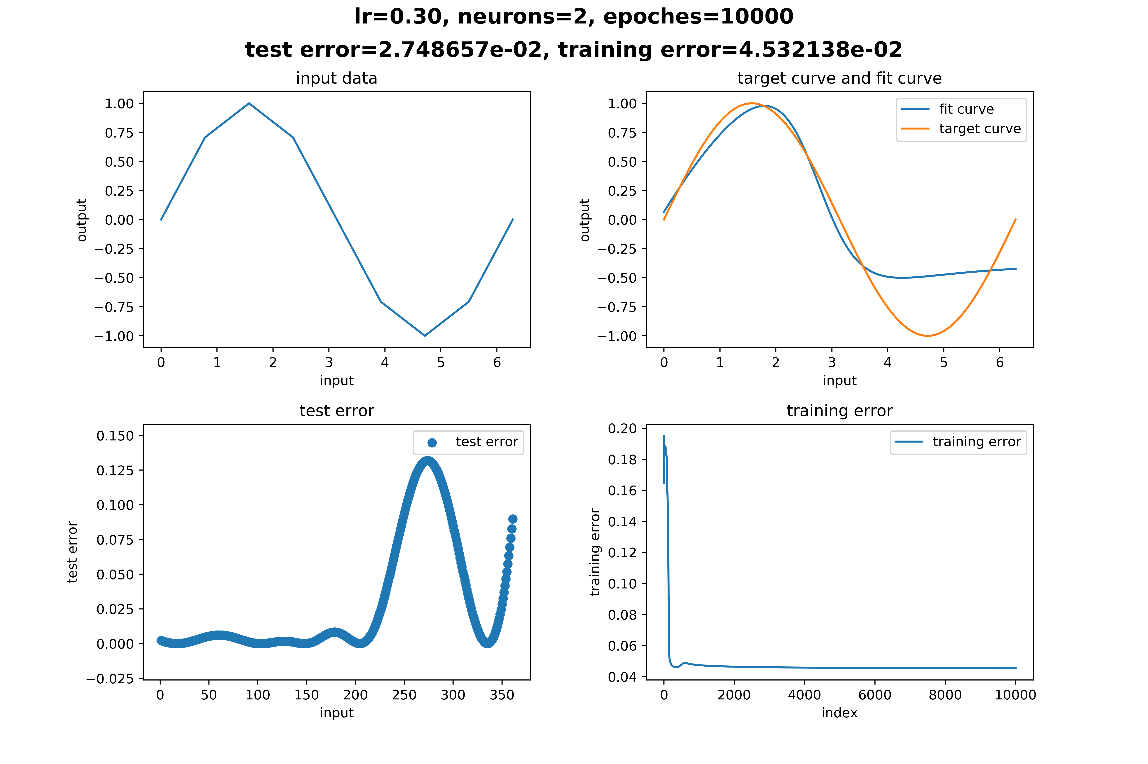

Figure num neurons = 2

As is shown in the subplot2, it is obvious that the fit curve is not so satisfactory. From subplot2 and subplot3, we can find that when x is near 4 and 5, the error is extremely large. Analyzing the variation of the training error, we can find that the training error converges at $4.532138×{10}^{-2}$. And the test error is $2.748657×{10}^{-2}$. This reason may be that there are so little neurons that the global minimum of the error surface can’t be small enough. Another reason may be the decrease of the number of neurons leads to the decrease of converge speed.

The above two figures illustrated that when the number of neurons equals 3, the neural network is powerful enough to fit the target curve, while when the number of neurons equals 2, the neural network is too weak to fit the target curve. It’s interesting to find out what will happen when the number of neurons increases.

The following picture shows the training result when the number of neurons increases from 20-50:

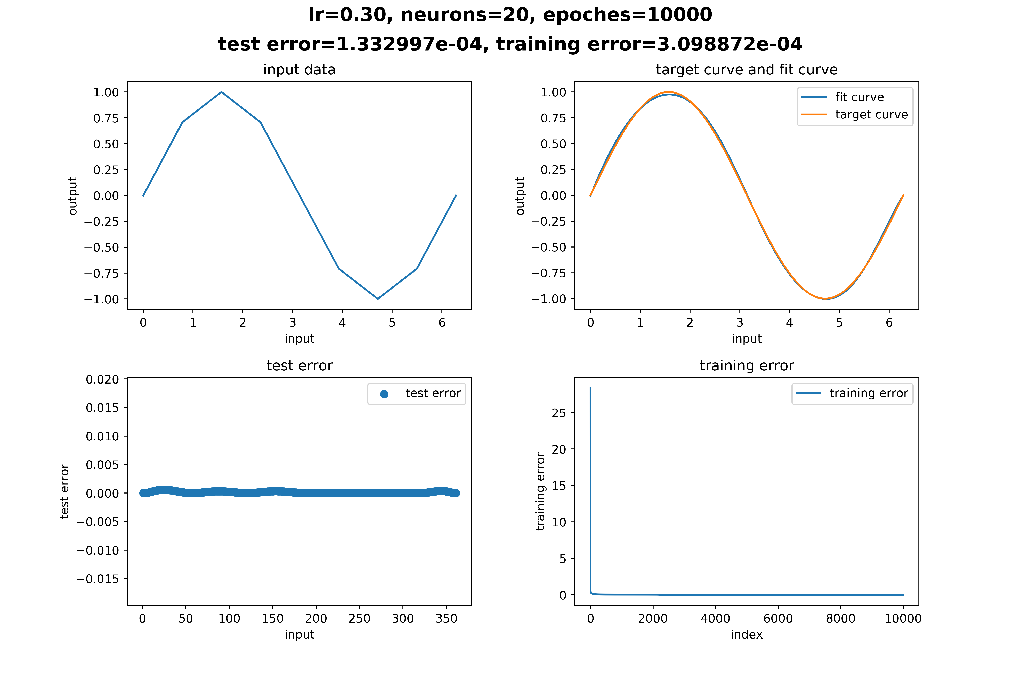

Figure num neurons = 2

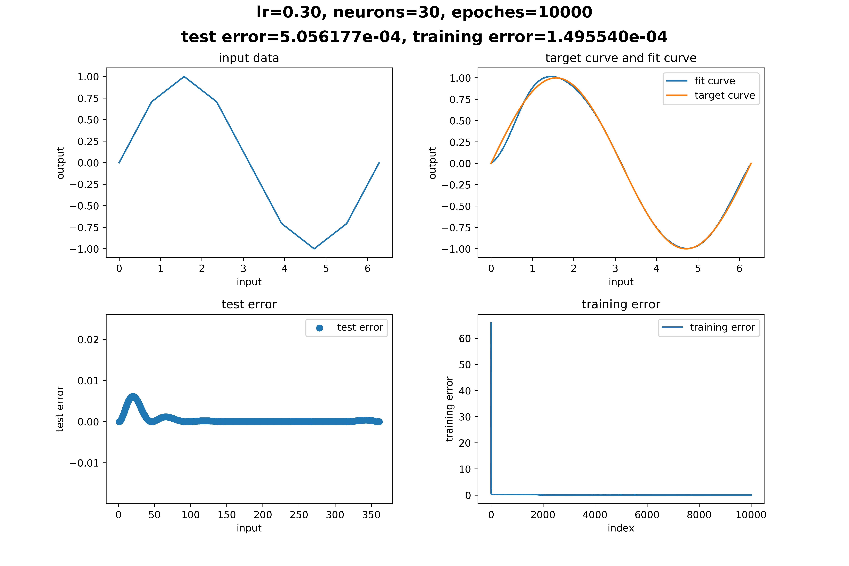

Figure num neurons = 30

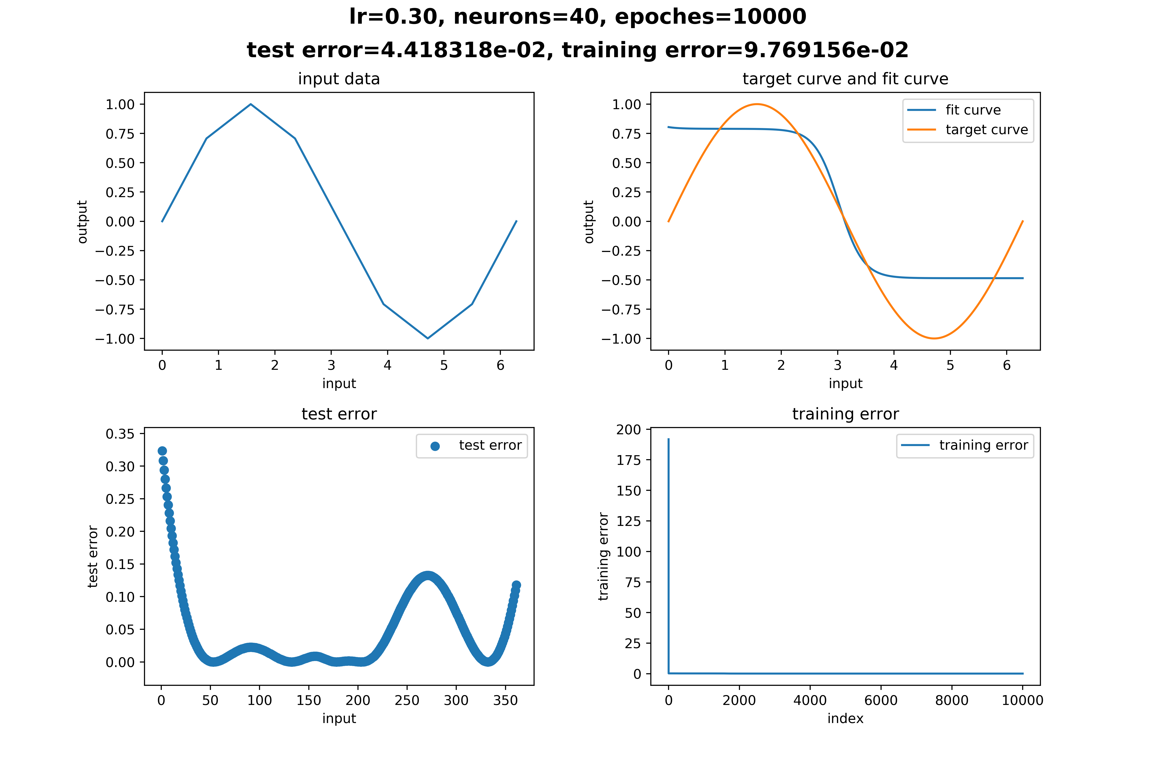

Figure num neurons = 40

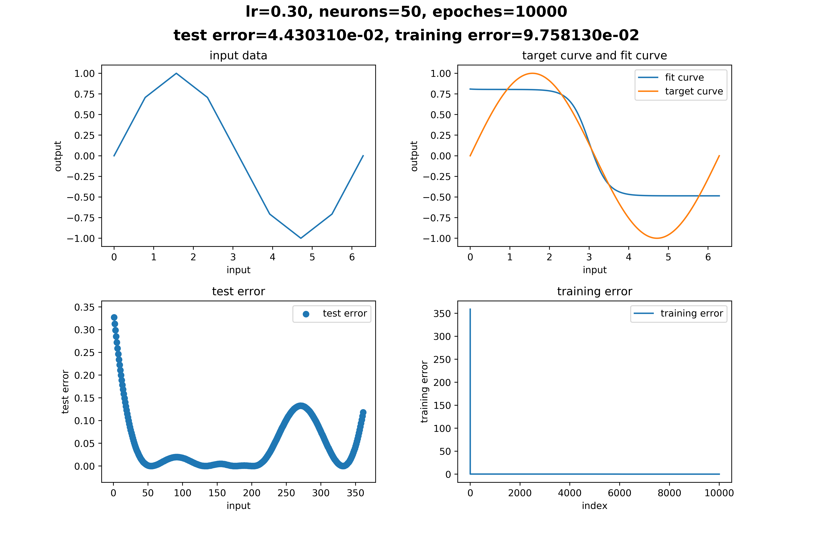

Figure num neurons = 50

Comparing the above figures, we can find that the increase of neurons does not necessarily makes the neural network more powerful. On the contrary, the result becomes worse when the number of neurons increases. As is shown in the figure, the network converges slowly and the error is large when the number of neurons increases.

1. How learning rate influences the training process

Then I kept the number of neurons at 50, and decreased the learning rate of the model, so as to see how learning rate influences the training process. The result is shown below:



Figure learning rate = 0.3

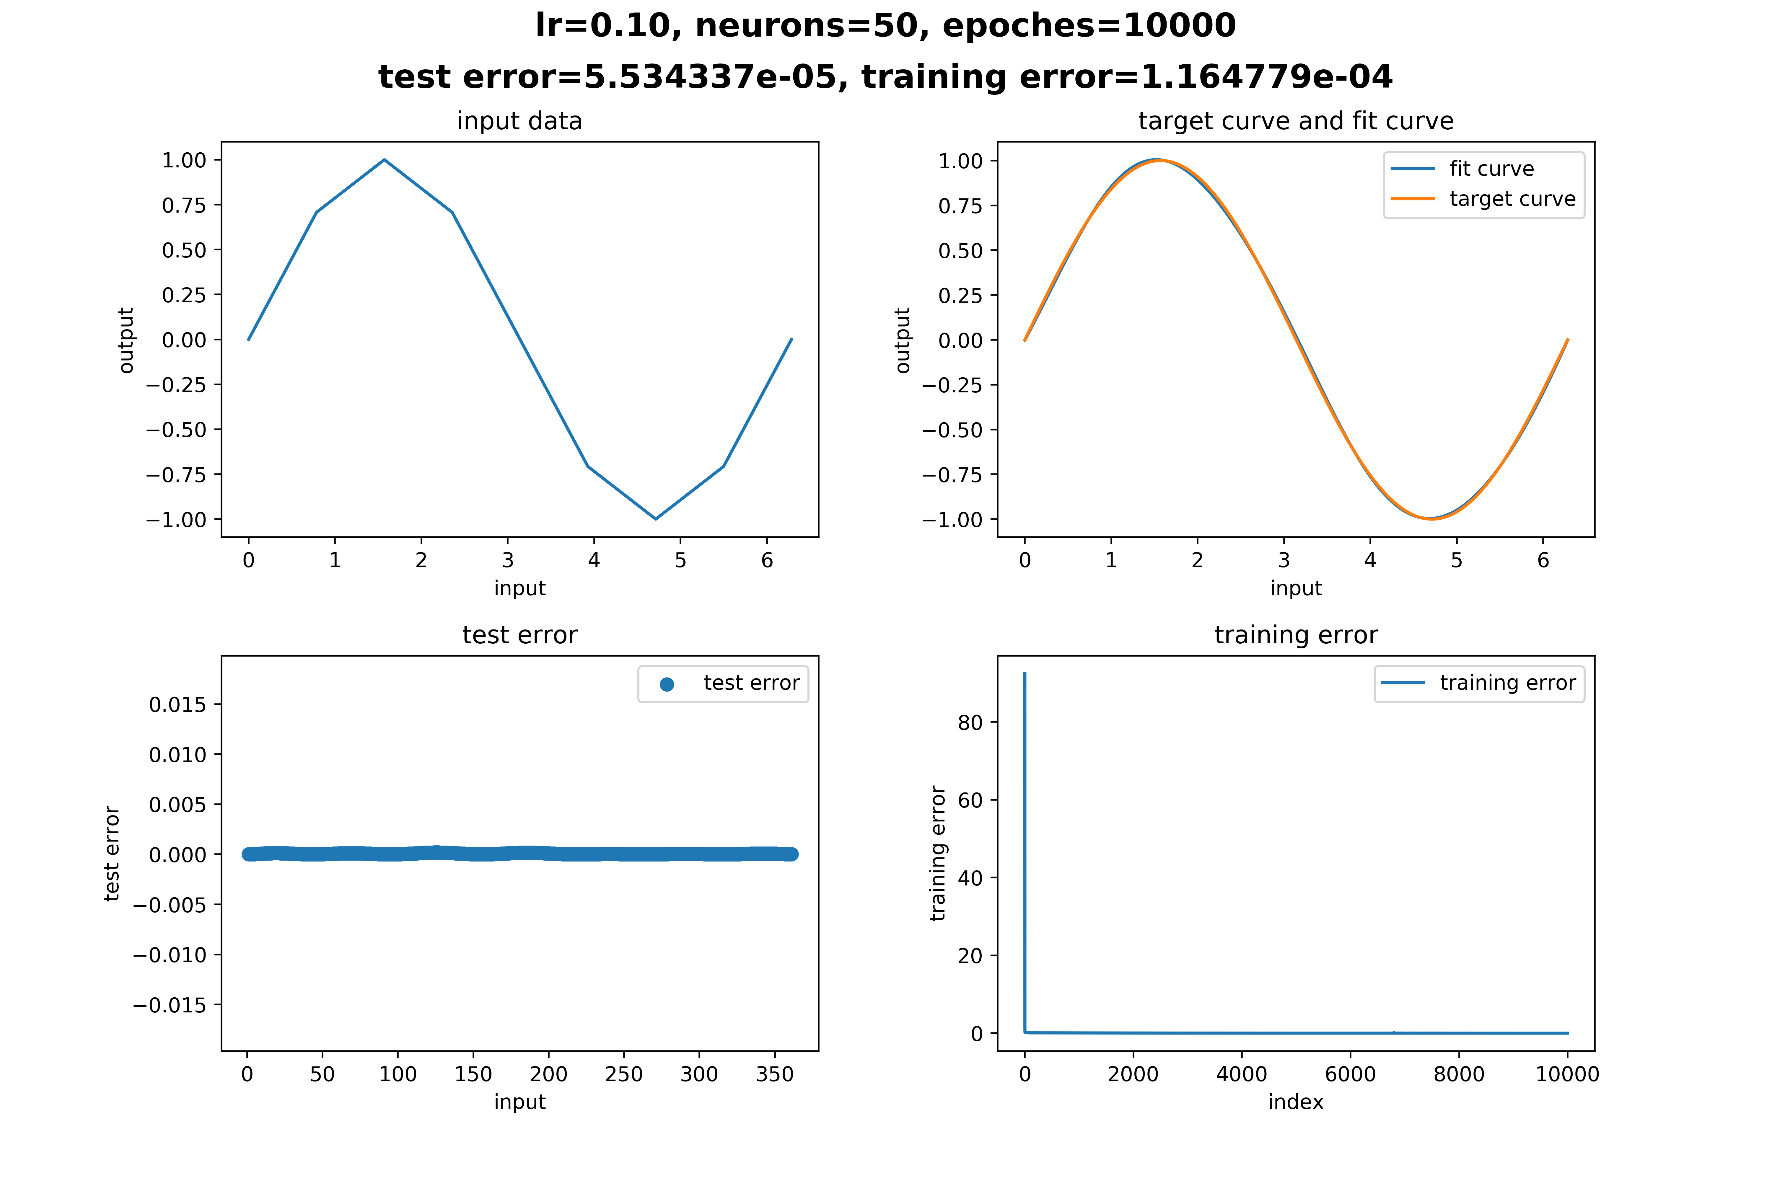

Figure learning rate = 0.1

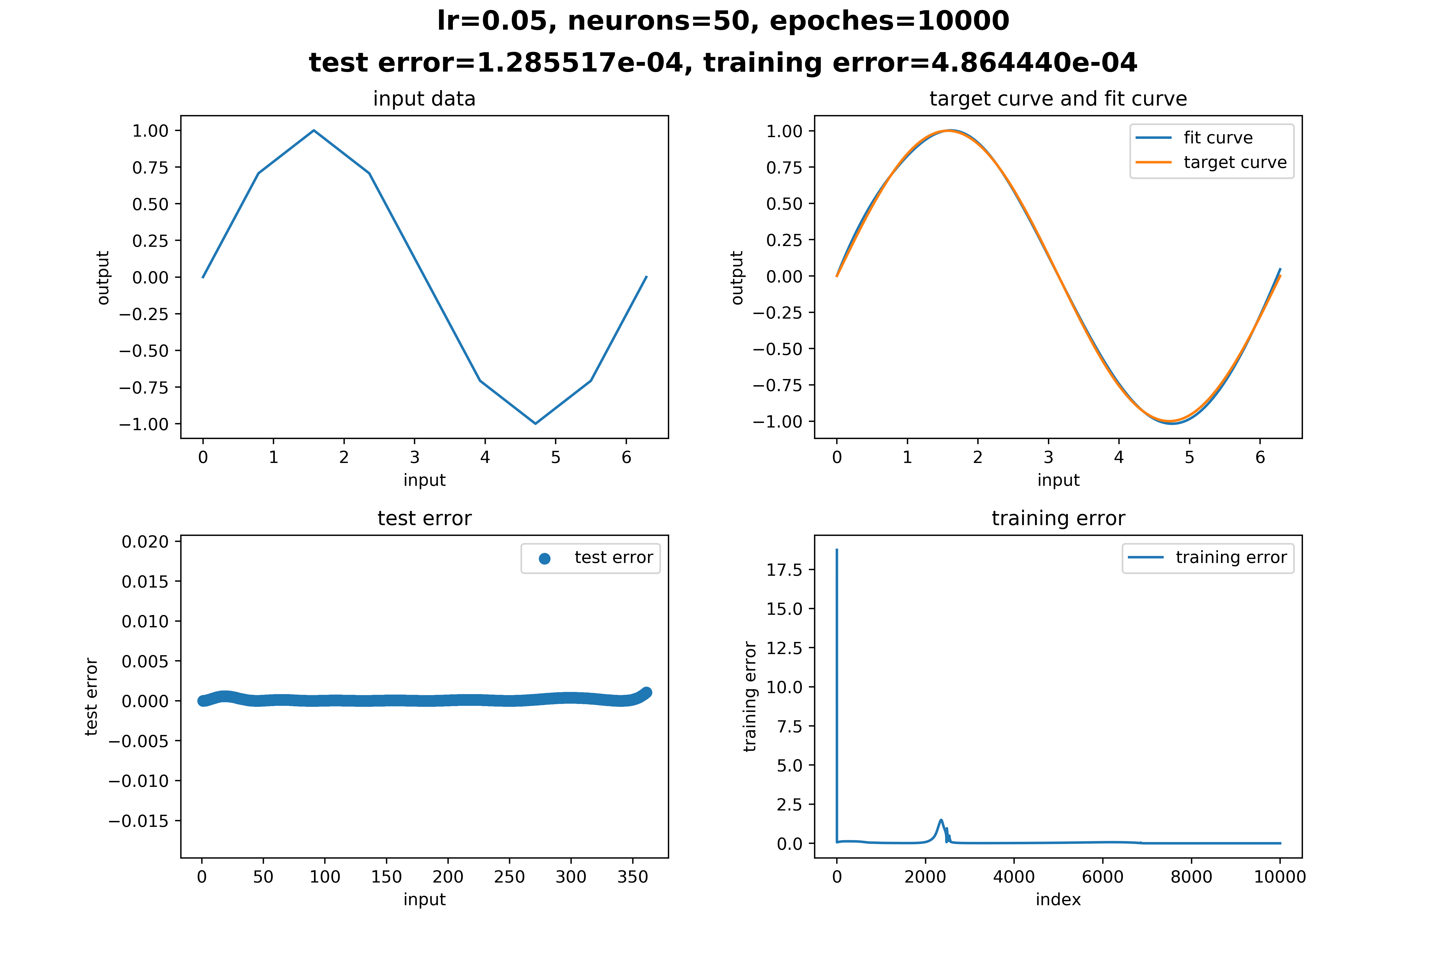

Figure learning rate = 0.05

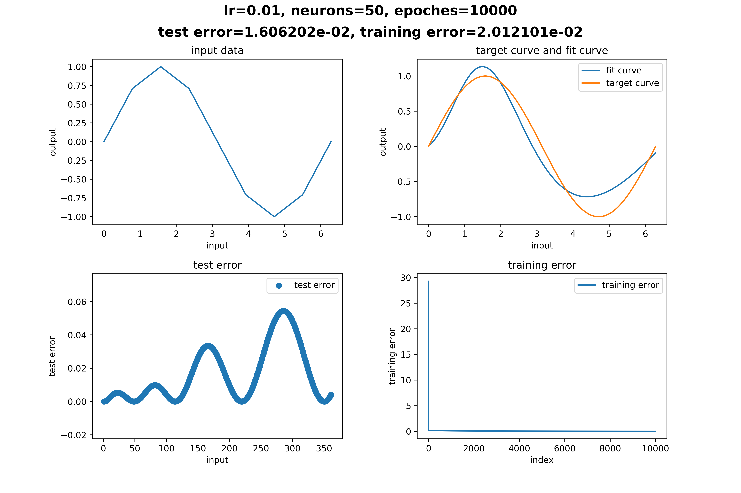

Figure learning rate = 0.01

The above images showed that though the model(50neurons) performs bad when learning rate kept 0.3, it converges well when the learning rate is decreased. But when learning rate becomes too small a number, the model will again converge slowly and performs bad as is shown in Figure 17.

But think about why this will happen? Then I repeated the above procedure when the number of neurons equals 10. The result is shown below:

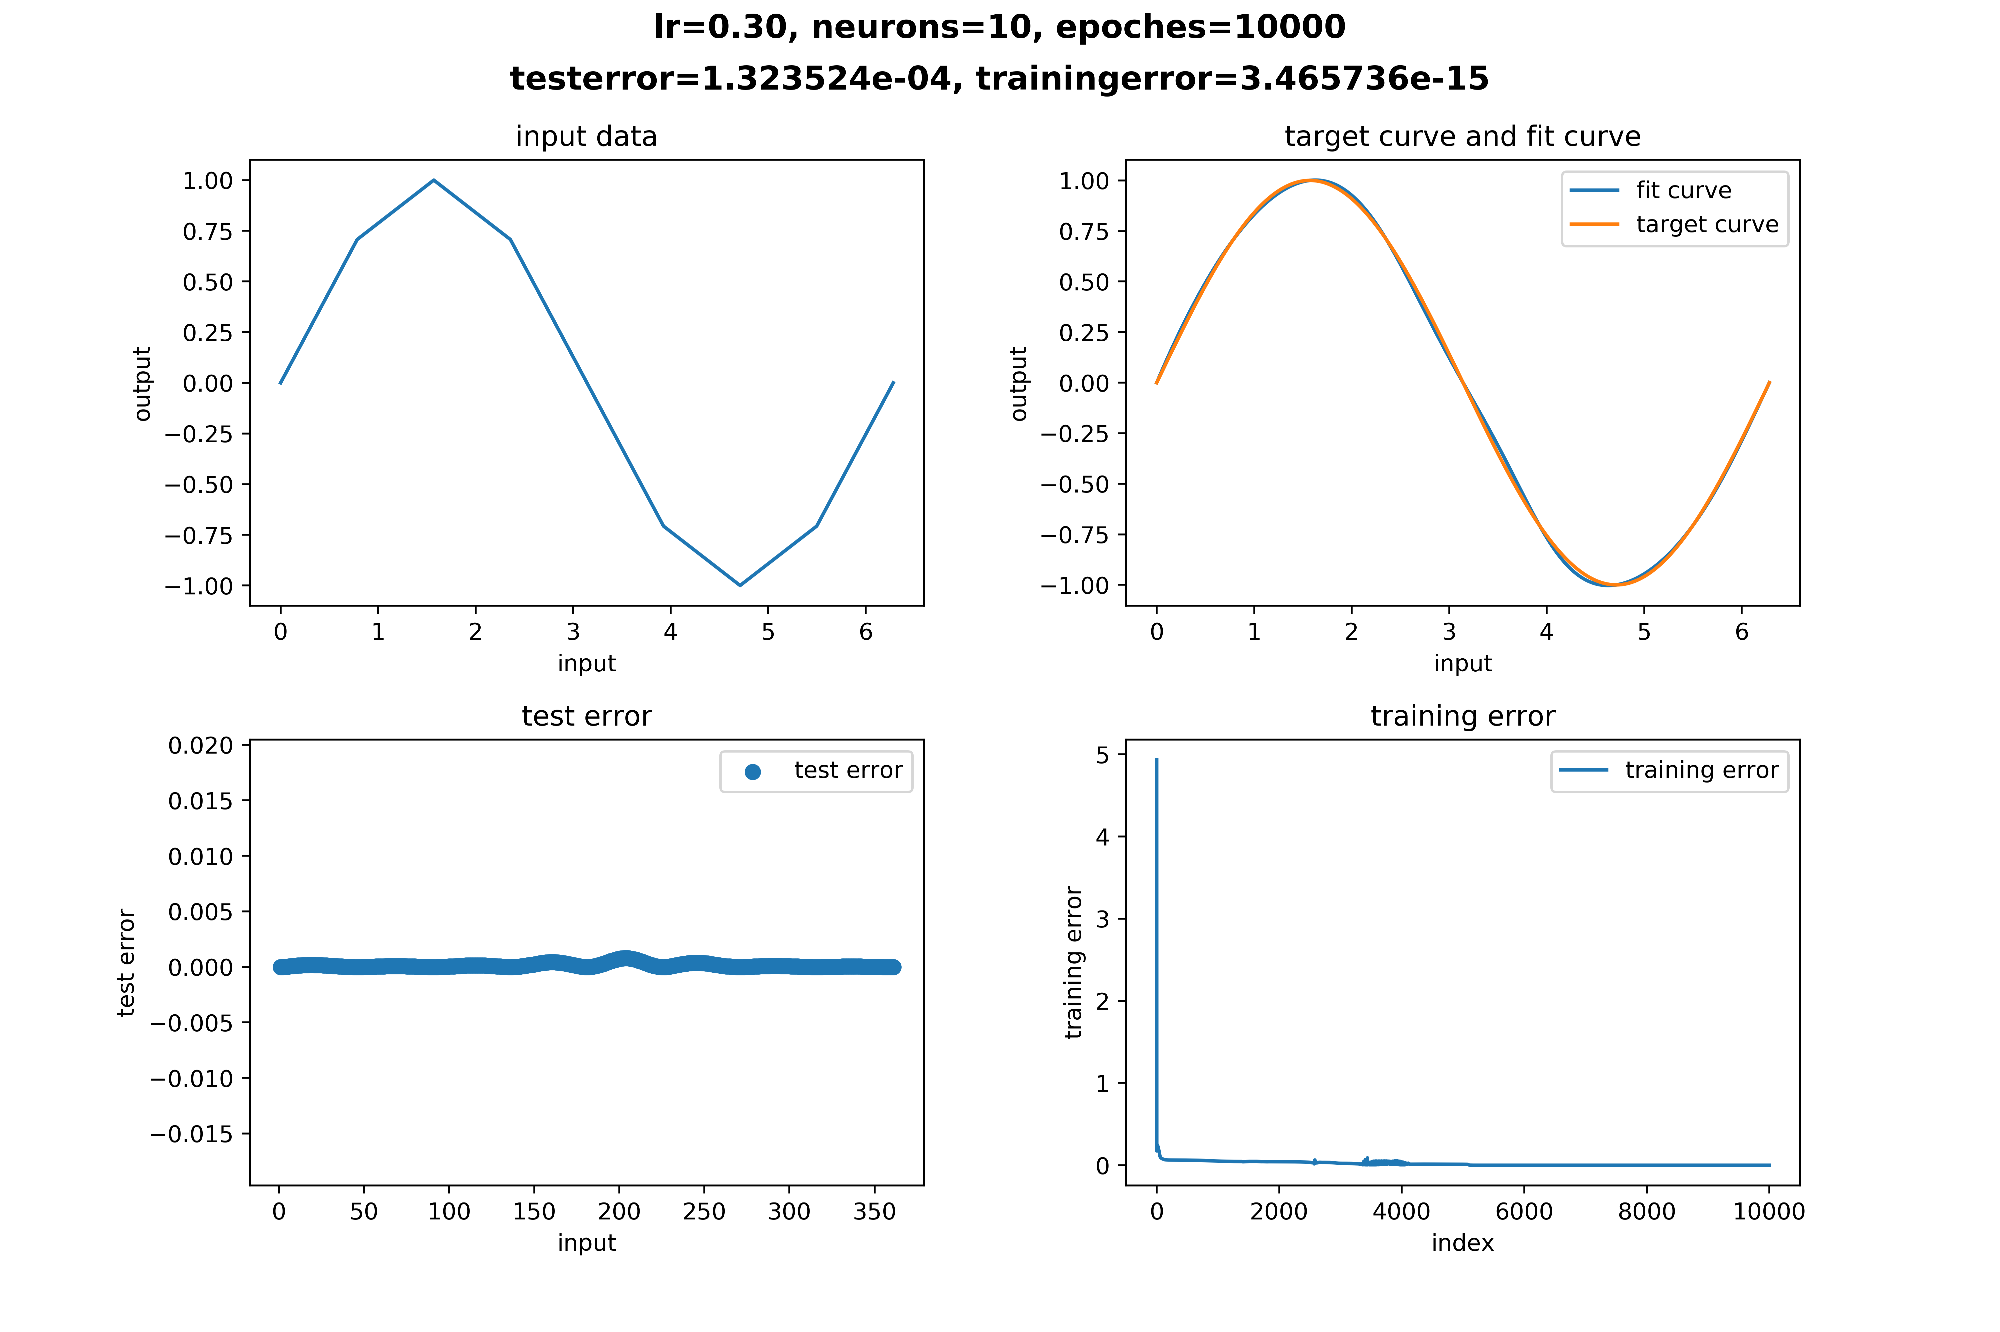

Figure learning rate = 0.3

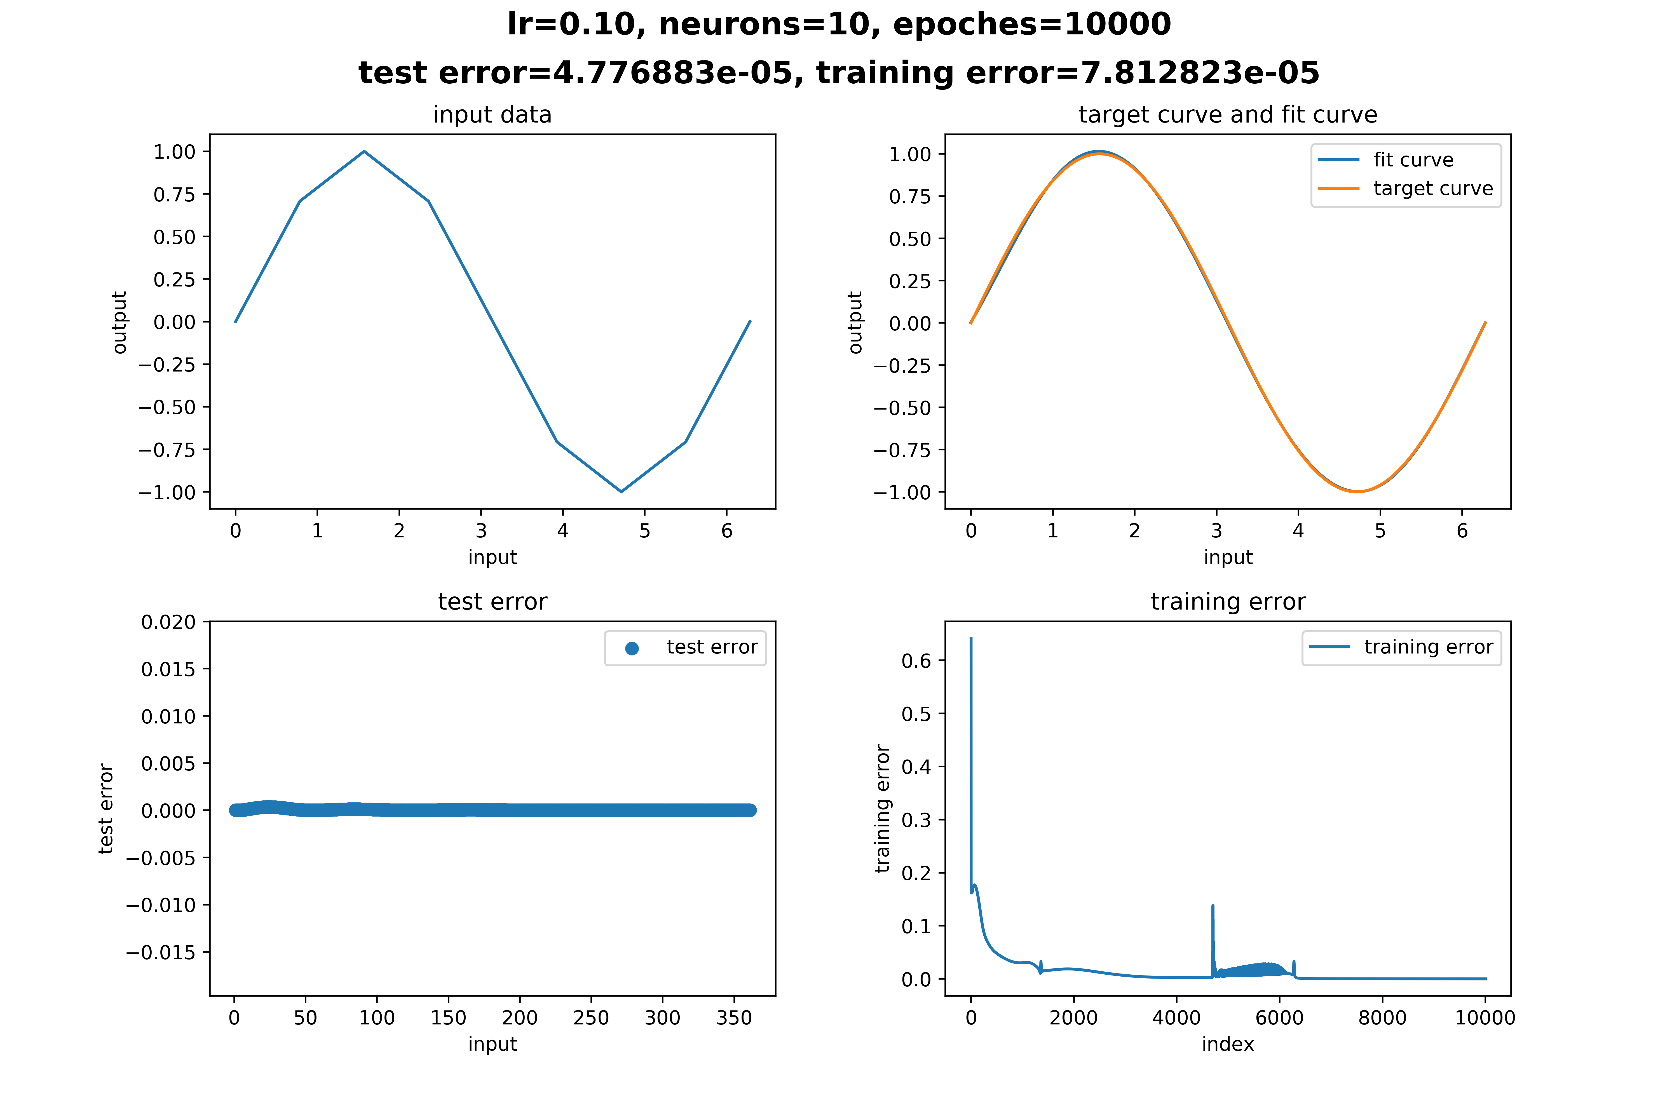

Figure learning rate = 0.1

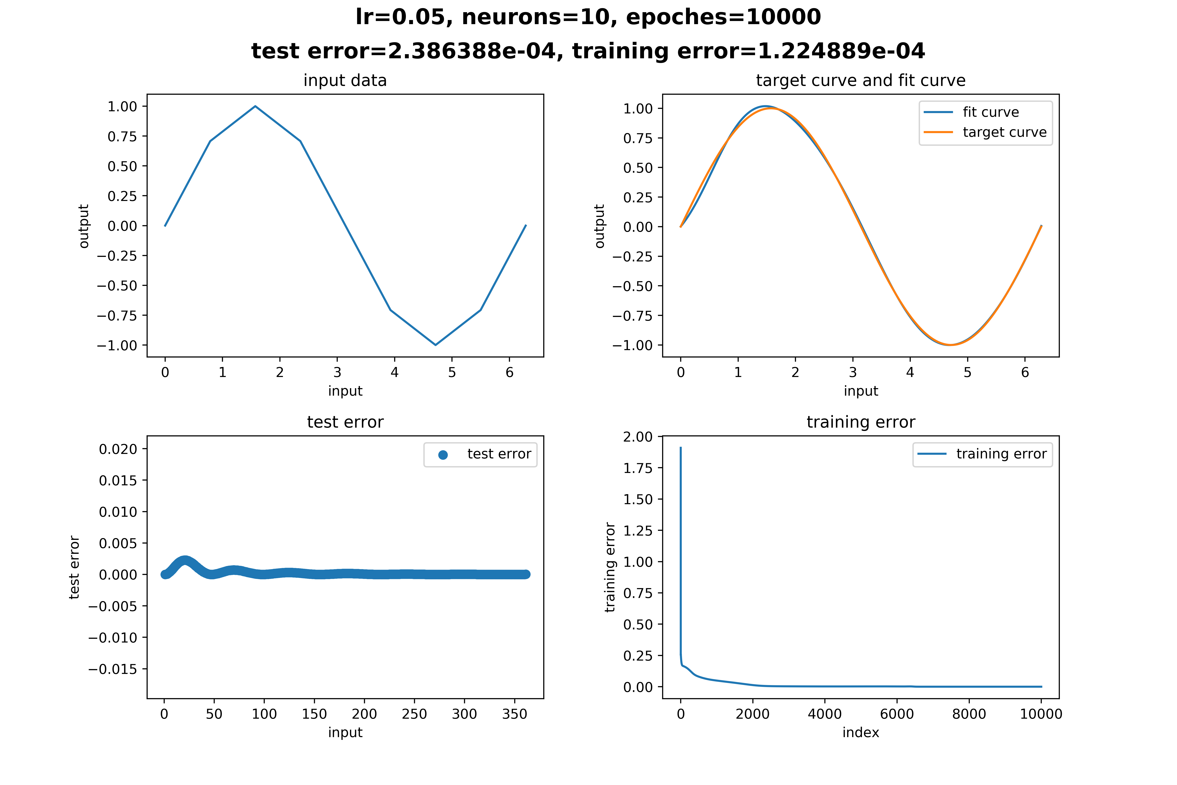

Figure learning rate = 0.05

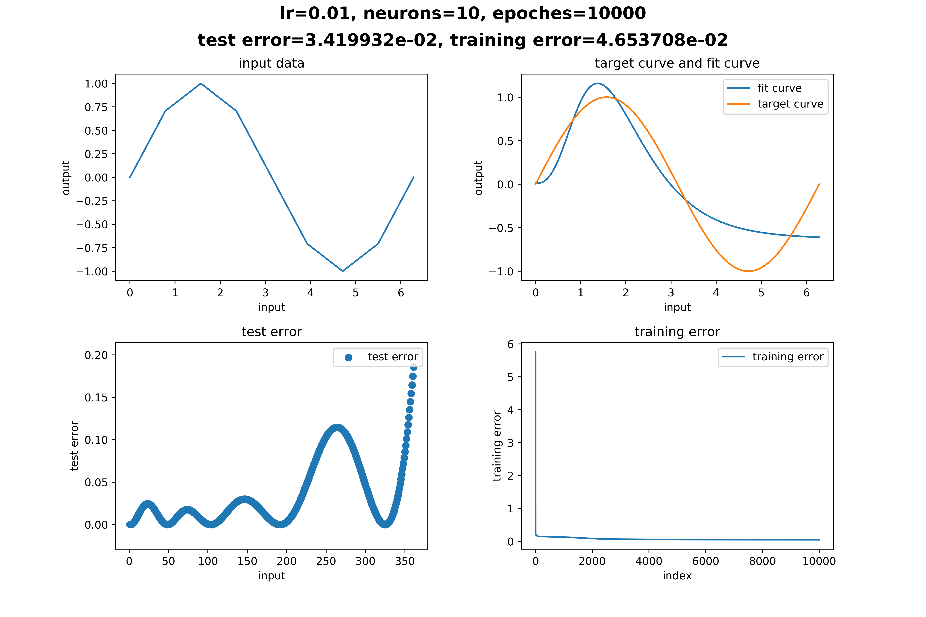

Figure learning rate = 0.01

From the above image, we can find that when the number of neurons equals 10, the model converges best when learning rate equals 0.3.

Then I repeated the procedure again when the number of neurons changes, the result is shown in the following table.

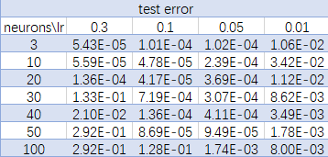

Figure 22 the value of test error when the number of neurons and learning rate varies (training epochs = 10000)

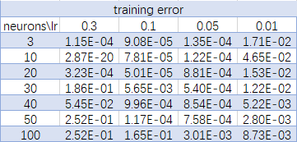

Figure 23 the value of training error when the number of neurons and learning rate varies (training epochs = 10000)

From the above tables, we can conclude that the model converges slower when the number of neurons gets larger. And if the number of neurons gets larger, learning rate should be decreased so that the model can converges faster.

Contrary to the common sense, the learning rate may not be better when it gets bigger. It is something that need to be corrected through the structure of the model.

To improve the performance of the model further, a method called learning rate decay can be applied. But the performance in this task is good enough, so it’s not necessary to use this method.

$y=\frac{sin⁡(x_{1})}{x_{1}}*\frac{\sin\left(x_{2}\right)}{x_{2}},x_{1},x_{2}∈[-10, 10]$

To approximate a two-dimensional function, the following MLP neural network is given.

As is shown in Figure 24, the MLP consists of one hidden layer with ten neurons, one input layer and one output layer. What needs to be emphasized is that the output layer can be thought as a general neuron but without the activation function. This is because the sigmoid function is a single direction function, which means it can not output negative value. With the sigmoid function removed, the sine function can be fitted.

Apply this network in python and set learning rate as 0.1, epochs as 10000. Then train it with 121 sample input ranging from $x_{1},x_{2}∈\left[-10,+10\right].$

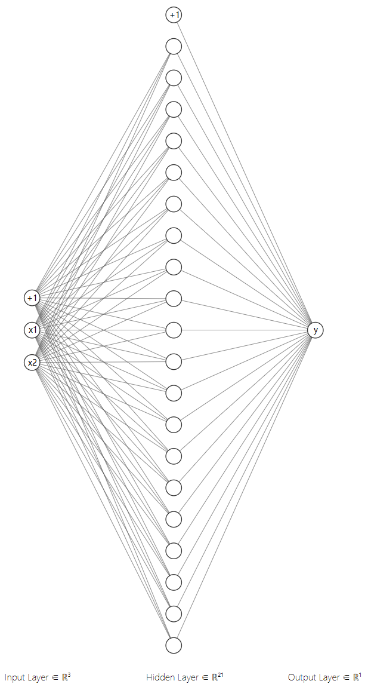

Figure 24 MLP for two-dimensional function

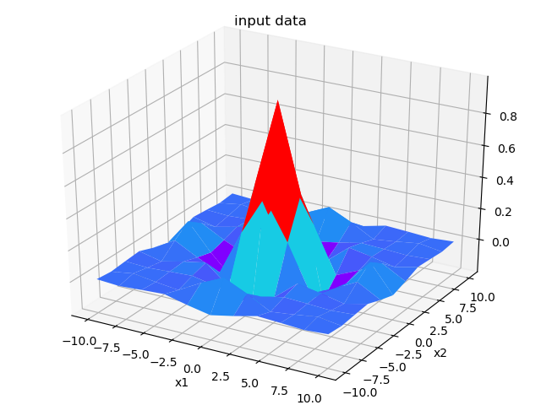

Figure input data

After training 10000 epochs, the neural network can excellently approximate the input sine curve. Plot the target curve and the fit curve in one figure with matplotlib, the result is shown below:

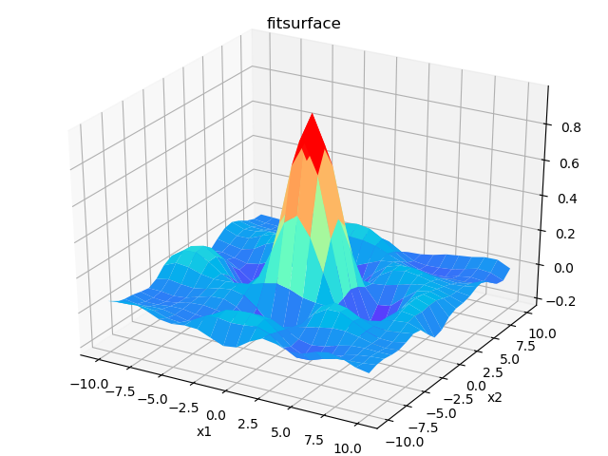

Figure fit surface

At first glimpse, we can find that the fit surface mimics the target surface. But it’s not clear enough to compare the two surfaces separately. So, I came up with the following plot. The surface shown below is the target surface, and the dots in the plot are the dots on the fit surface.

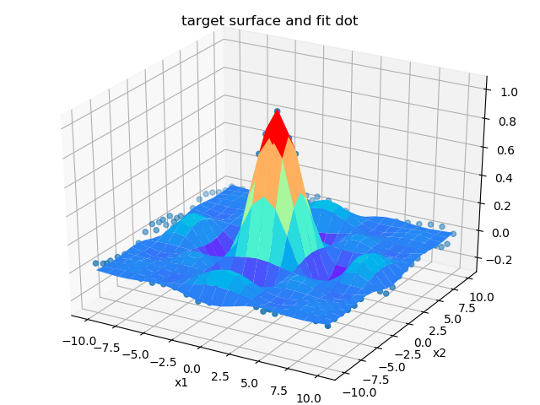

Figure fit surface and fit dot

But it’s still not clear enough for us to find out if the model works well. If the Z axis is substituted for test error, we have the following plot. We can clearly find that the test error is generally low but a little bit large on the edge.

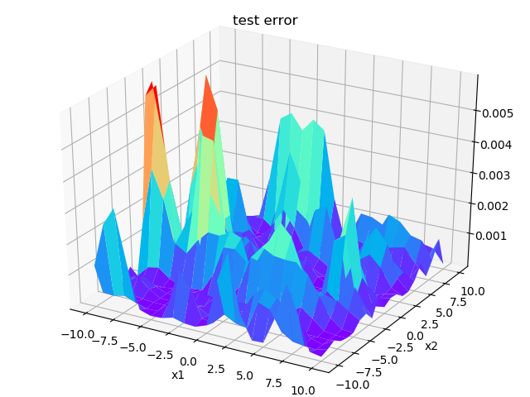

Figure test error

Record the training error in each epoch and plot the training error curve. The x-coordinate is the number of iterations and the y-coordinate is the training error. The figure is shown below:

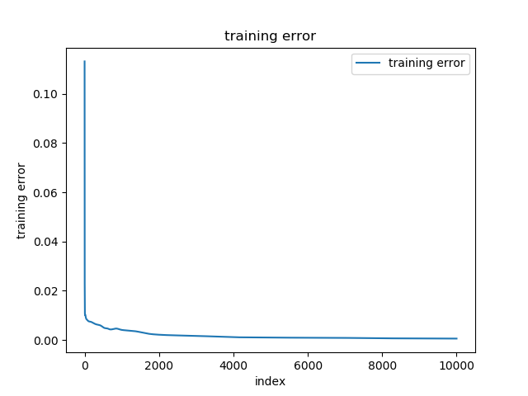

The training error equals 0.0005437500181105242 and the test error equals 0.0007072537034922483.

# results and discussions

# conclusion

# appendix and codes

## Types of Graphics

References

1. M.W Gardner, S.R Dorling, Artificial neural networks (the multilayer perceptron)—a review of applications in the atmospheric sciences

https://doi.org/10.1016/S1352-2310(97)00447-0.

(http://www.sciencedirect.com/science/article/pii/S1352231097004470)

1.